CS 255 System Design Document Template

UML Diagrams

UML Use Case Diagram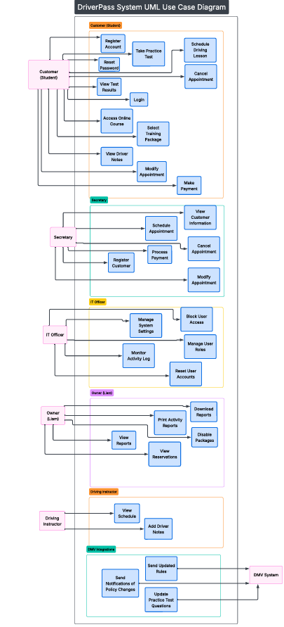

UML Activity Diagrams Use Case 1: scheduling driving lesson
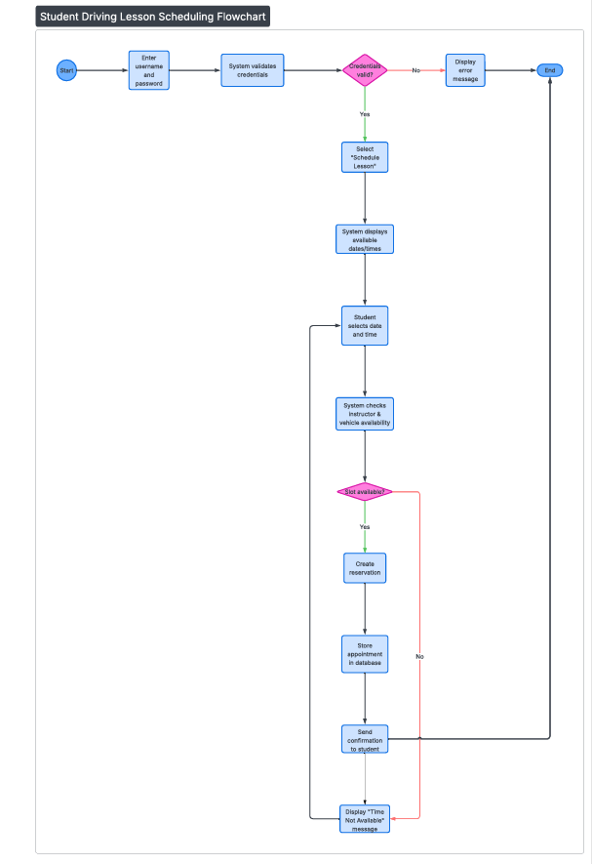

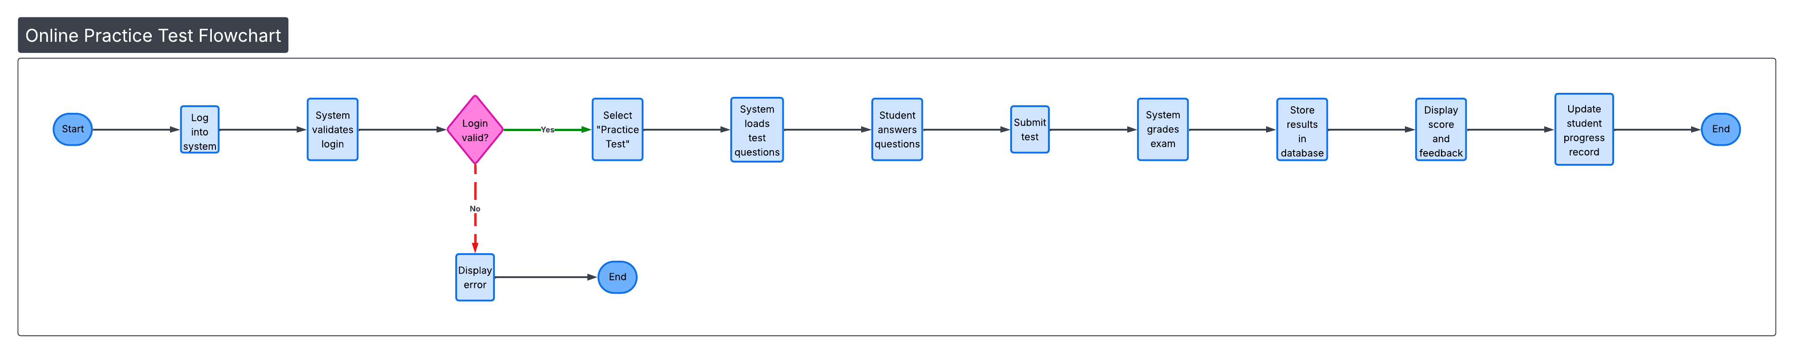
Case 2: Online practice test flowchart

UML Sequence Diagram

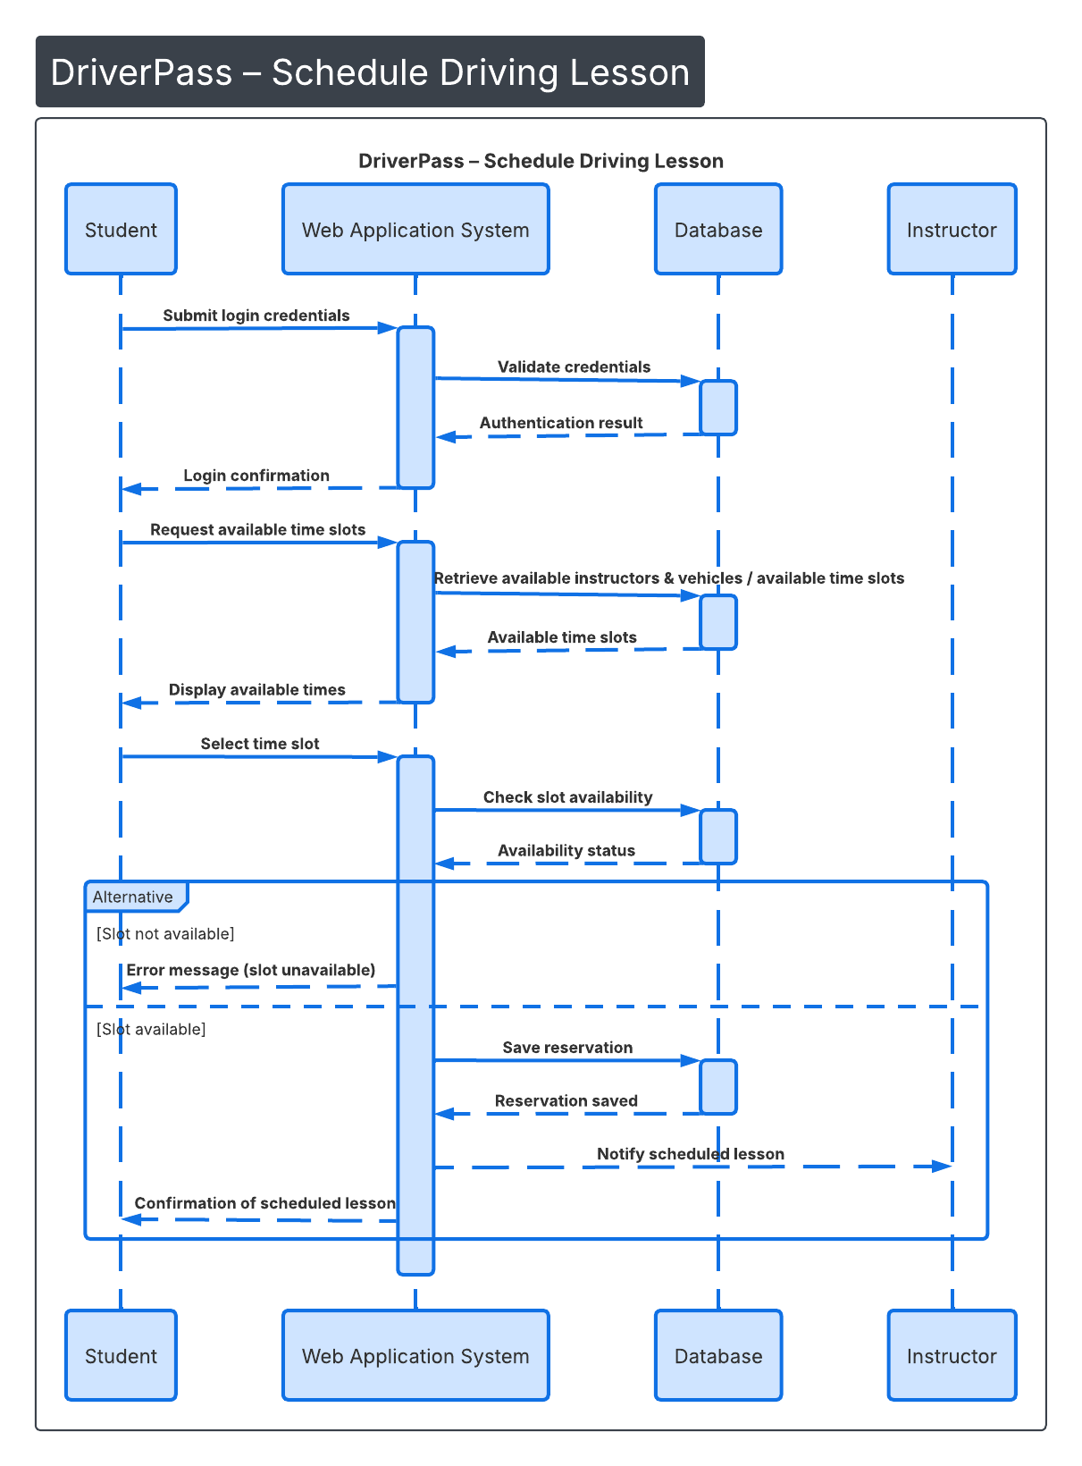

UML Class Diagram
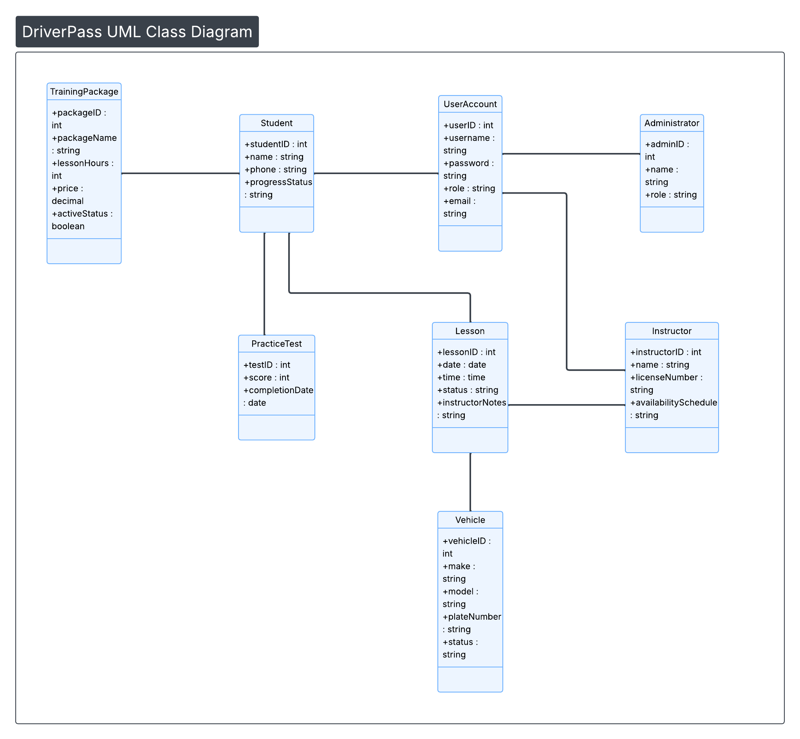

Technical Requirements
The DriverPass system will require appropriate hardware, software, security controls, and infrastructure to support scheduling, online testing, and account management functionality.
Hardware Requirements
The system shall require:
- A cloud-based web server hosts the DriverPass application.
- A dedicated database server for storing users, scheduling, and training data.
- Workstations for administrative staff and secretaries
- Mobile devices, tablets, or personal computers for students and instructors
- Reliable broadband internet connection
The system shall support a minimum of five hundred concurrent users without performance degradation.
Software Requirements
The system should be developed as a web-based application accessible through modern browsers such as Chrome, Edge, Firefox, and Safari.
The software components shall include:
- A web application framework (e.g., .NET, Java, or similar platform)
- A relational database management system (e.g., MySQL or SQL Server)
- Secure authentication and authorization mechanisms
- Integrated payment processing service for training package purchases
- Email notification service for lesson confirmations.
The system shall process user requests within 3 seconds under normal operating conditions.
Security Requirements
The DriverPass system shall implement the following security controls:
- Role-based access control (Student, Instructor, Secretary, Administrator)
- Encrypted password storage
- Secure HTTPS communication using SSL/TLS encryption.
- Automatic session timeout after 15 minutes of inactivity
- Daily automated data backups
- Activity logging to track account modifications, lesson scheduling changes, and administrative actions
The system shall maintain 99% uptime excluding scheduled maintenance.

Infrastructure Requirements
The system shall be hosted in a cloud-based environment to allow scalability and future expansion.
Infrastructure requirements include:
- Secure database storage
- Backup and disaster recovery procedures
- Firewall and intrusion detection protection.
- Continuous system monitoring
- Scalability to accommodate future feature expansion.
Performance Requirements
- The system shall support simultaneous lesson scheduling without conflicts.
- The system shall verify instructor and vehicle availability before confirming reservations.
- Online practice tests shall automatically grade and record results immediately upon submission.

